June 17, 2021

MR TERRY BOLES

PRESIDENT

GULF COAST GROWTH VENTURES LLC

1735 HUGHES LANDING BLVD HLE 07 S185

THE WOODLANDS TX 77380-1688

Re: Final Revised Permit Approval

Minor Revision

Permit Number: O4169

Expiration Date: December 30, 2025

Gulf Coast Growth Ventures LLC

Olefins, Derivative and Utilities

Gregory, San Patricio County

Regulated Entity Number: RN109753731

Customer Reference Number: CN605632439

Dear Mr. Boles:

The revised effective federal operating permit (FOP) for Gulf Coast Growth Ventures LLC, Olefins, Derivative and Utilities is enclosed. This letter constitutes authority to operate the changes identified in the FOP revision application.

Consistent with Title 30 Texas Administrative Code Chapter 122, Subchapter C, the permit holder shall submit an application to the Air Permits Division (APD) for a revision to an FOP for those activities at a site which change, add, or remove one or more FOP terms or conditions. The permit holder shall also submit an application to the APD for a revision to a permit to address the following: the adoption of an applicable requirement previously designated as federally enforceable only; the promulgation of a new applicable requirement; the adoption of a new state-only requirement; or a change in a state-only designation.

Consistent with 30 TAC §122.133 and 30 TAC §122.134, a complete renewal application must be submitted to the agency no later than six months, but no earlier than 18 months, before the expiration of this permit.

Thank you again for your cooperation in this matter. If you have questions concerning the review or this notice, please contact Mr. Vasant V. Chaphekar, P.E. at (512) 239-1341.

This action is taken under authority delegated by the Executive Director of the Texas Commission on Environmental Quality.

Sincerely,

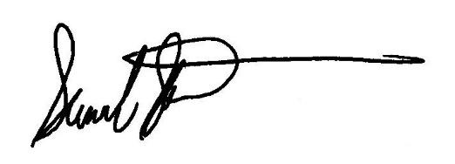

Samuel Short, Deputy Director

Air Permits Division

Office of Air

Texas Commission on Environmental Quality

cc: Ms. Hanh Tran, Environmental Advisor, Gulf Coast Growth Ventures LLC, Gregory

Air Section Manager, Region 14 - Corpus Christi

Enclosure: Revised Effective Permit

cc: Air Permit Section Chief, U.S. Environmental Protection Agency, Region 6, Dallas

Project Number: 31659