February 26, 2020

THE HONORABLE JUDITH ZAFFIRINI

TEXAS SENATE

PO BOX 12068

AUSTIN TX 78711-2068

Re: Accepted Federal Operating Permit Initial Issuance Application

Project Number:  29423

Permit Number:  O4169

Gulf Coast Growth Ventures LLC

Olefins, Derivative And Utilities

Gregory, San Patricio County

Regulated Entity Number:  RN109753731

Customer Reference Number:  CN605632439

Dear Senator Zaffirini:

This letter notifies you that the Texas Commission on Environmental Quality has received a federal operating permit (FOP) initial issuance application for a site located in your district. As part of this permitting process, the applicant is required to publish a formal newspaper public notice. The notice will inform the public of their right to make comments or request a public hearing. This link to an electronic map of the site or facility's general location is provided as a public courtesy and not part of the application or notice. For exact location, refer to application. <http://www.tceq.texas.gov/assets/public/hb610/index.html?lat=27.929722&lng=-97.321944&zoom=13&type=r>.

The FOP program regulates both new and existing major sources of emissions. The goal of the program is to improve air quality in Texas through increased compliance by codifying existing applicable regulatory requirements into the FOP. The FOP provides the applicant authorization to operate the equipment at the site. The FOP identifies and codifies air emission requirements (known as applicable requirements) that apply to the emission units at the site. The FOP does not authorize construction of emission units or emissions from those units. The New Source Review (NSR) permit is the mechanism for these authorizations.

This letter is being sent to you for information only and no action is required. If you need further information, please contact me at (512) 239-1250.

Sincerely,

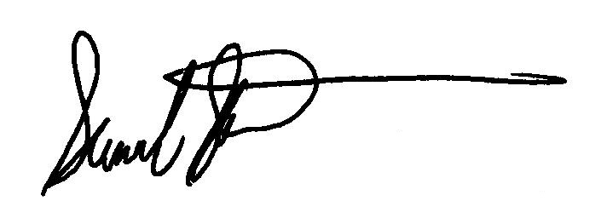

Samuel Short, Director

Air Permits Division

Office of Air

Texas Commission on Environmental Quality

February 26, 2020

THE HONORABLE JOSE M LOZANO

TEXAS HOUSE OF REPRESENTATIVES

PO BOX 2910

AUSTIN TX 78768-2910

Re: Accepted Federal Operating Permit Initial Issuance Application

Project Number:  29423

Permit Number:  O4169

Gulf Coast Growth Ventures LLC

Olefins, Derivative And Utilities

Gregory, San Patricio County

Regulated Entity Number:  RN109753731

Customer Reference Number:  CN605632439

Dear Representative Lozano:

This letter notifies you that the Texas Commission on Environmental Quality has received a federal operating permit (FOP) initial issuance application for a site located in your district. As part of this permitting process, the applicant is required to publish a formal newspaper public notice. The notice will inform the public of their right to make comments or request a public hearing. This link to an electronic map of the site or facility's general location is provided as a public courtesy and not part of the application or notice. For exact location, refer to application. <http://www.tceq.texas.gov/assets/public/hb610/index.html?lat=27.929722&lng=-97.321944&zoom=13&type=r>.

The FOP program regulates both new and existing major sources of emissions. The goal of the program is to improve air quality in Texas through increased compliance by codifying existing applicable regulatory requirements into the FOP. The FOP provides the applicant authorization to operate the equipment at the site.

This letter is being sent to you for information only and no action is required. If you need further information, please contact me at (512) 239-1250.

Sincerely,



Samuel Short, Director

Air Permits Division

Office of Air

Texas Commission on Environmental Quality